 **FAF-191 | Basso Nicolae**

**Lab - Research IT and Networking Job Opportunities**

**Objectives**

* Research Job Opportunities

**Background / Scenario**

Jobs in Information Technology (IT) and computer networking continue to grow. Most employers require some form of industry standard certification, degree, or other qualifications from their potential employees, especially those with limited experience. The Cisco CCNA certification is a known and established entry-level networking certification that is respected in the industry. There are additional levels and kinds of Cisco certifications that one can attain, and each certification may enhance employment opportunities as well as salary range.

In this lab, you will complete targeted job searching on the web to find what types of IT and computer networking jobs are available; what kinds of skills and certifications you will need; and the salary ranges associated with the various job titles.

**Required Resources**

* Device with Internet access

**Instructions**

You will use a web browser to visit the popular job listing websites, such as monster.com and salary.com.

I will use **rabota.md** instead to able to find most offers on the local market.

**Step 1: Open a web browser and go to a job listing website.**

In the URL address bar type [http://monster.com](http://monster.com/) and press Enter.

**Note**: For job listings outside of the U.S., use the following link to search for your country:

<http://www.monster.com/geo/siteselection/>

**Step 2: Search for networking related jobs.**

1. Type the word ***Network Administrator*** in the **Keyword or Title** box. Click **Find Jobs** to continue.

**117 vacancies found** 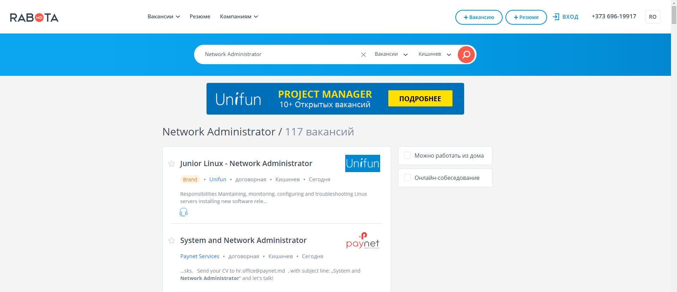

1. Notice the search results. Now, focus your search by adding terms to the search for Network Administrator. Try terms like Cisco CCNA, CCNP, CCNA Security, CCNA Voice, etc.

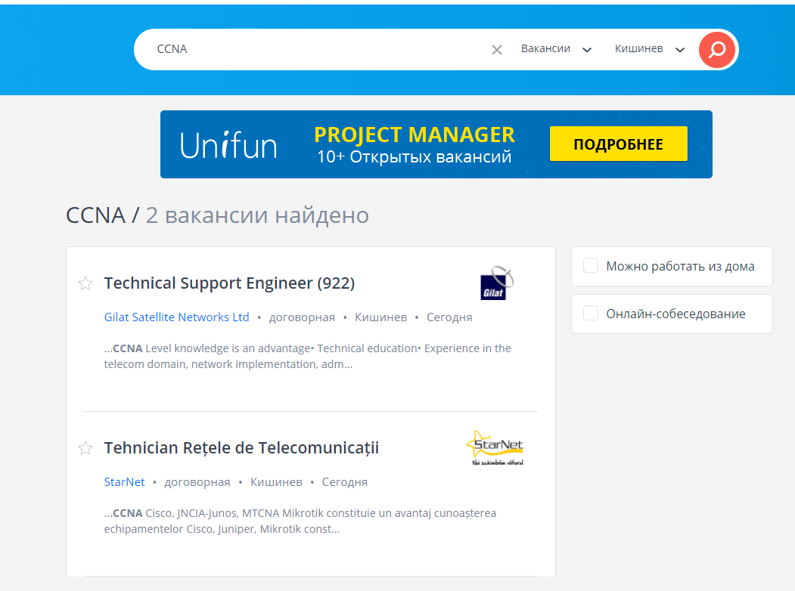

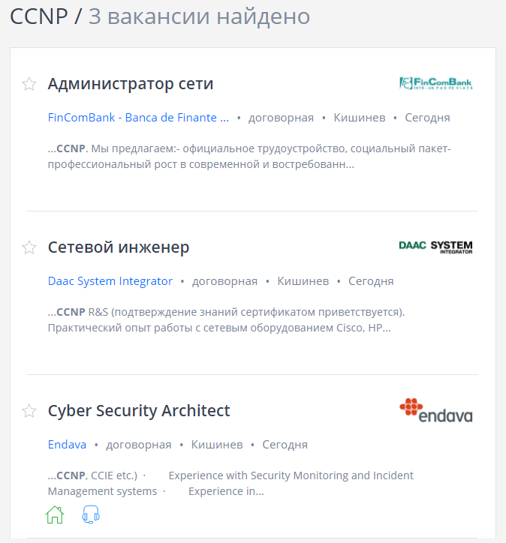

Other terms do not result anything in search.

1. Now try refining your search by adding different geographical locations. Did you find jobs in the locations you entered?

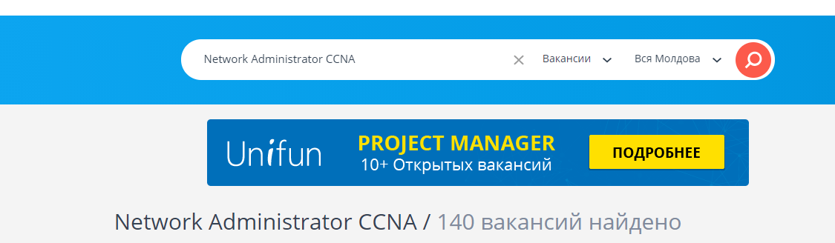

Adding all cities within Moldova led to +23 search results.

***Type your answers here.***

1. Try searching a different website. Go to [http://www.salary.com](http://www.salary.com/) and click the Job Search menu bar button. **Note**: For salary listings outside of the U.S., use the following link to search for your country:<http://www.payscale.com/rccountries.aspx>
2. Add a search term like ***Information Technology*** to the J**ob title or Keyword** field box and click **Get my** **salary estimate**.
3. Note the large number of matching search results. Select a job title that interests you. Click **SHOW MY** **SALARY ESTIMATE RESULTS**.

© 2013 - 2019 Cisco and/or its affiliates. All rights reserved. Cisco Public Page **1** of **2** www.netacad.com

**Lab - Research IT and Networking Job Opportunities**



1. Spend time searching for jobs and looking through the search results. Take note of what skills are required for different job titles and the range of starting salaries.

Usual requirements:

* Proficiency in system administration
* Proficiency in server administration on Linux (Ubuntu, Centos) LAMP
* Experience with VPN (OpenVPN, IPSEC)
* Experience with Nginx, Apache, MySQL, Asterisk
* Advanced proficiency in writing scripts(bash)
* Experience with monitoring systems: Nagios, Zabbix, etc.
* Knowledge of SIP, SIGTRAN, SMPP protocols is a plus

**Reflection Questions**

Answer the following questions based on your research findings.

1. What job titles did you search for?

Network Administrator, CCNA Routing and Switching, CCNA Collaboration, CCNA Cloud, Cisco CCNA, CCNP, CCNA Security, CCNA Voice, CCNA Cyber Ops.

1. What skills or certifications were required?

* Advanced proficiency in system administration
* Advanced proficiency in server administration on Linux (Ubuntu, Centos) LAMP
* Experience with VPN (OpenVPN, IPSEC)
* Experience with Nginx, Apache, MySQL, Asterisk
* Advanced proficiency in writing scripts(bash)
* Experience with monitoring systems: Nagios, Zabbix, etc.
* Knowledge of SIP, SIGTRAN, SMPP protocols is a plus
* Good knowledge of server administration on Linux (Ubuntu, Centos)and on Windows Server (2008, 2012R2)
* Work experience with network devices (Cisco, HP)
* Understanding of VPN (OpenVPN,IPSEC)
* Good knowledge of Hyper-V, VMware ESXi; Active Directory, IIS, Apache, DNS, firewall, Monitoring Systems (Zabbix etc.)
* Basic knowledge of MS SQL, MySQL Administration
* Ability to write scripts
* Good command of English will be an advantage

***Type your answers here.***

1. Did you find any jobs that you previously did not know existed? If so, what were they?

Yes, some of the job titles seemed to me quite unclear, such as “Intelligence analyst”, “Digital forensics”.

*Intelligence analyst – the one who who pieces together information from a variety of sources in order to assess threats and prevent attacks from interior and exterior enemies.*

*Digital forensics - is the process of identifying, preserving, analyzing, and documenting digital evidence. This is done in order to present evidence in a court of law when required. Digital forensics is the process of uncovering and interpreting electronic data.*

***Type your answers here.***

1. Did you find any jobs that you are interested in? If so, which ones and what skills or certifications do they require?

***Type your answers here.***

Many jobs for which I was looking for during the lab felt reasonably interesting to me. Looks like all of them require nothing unexpected: strong knowledge of English, CCNA certificate, experience working with networking tools.

© 2013 - 2019 Cisco and/or its affiliates. All rights reserved. Cisco Public Page **2** of **2** www.netacad.com